 | EUROPEAN COMMISSION  DIRECTORATE-GENERAL  INFORMATICS  Information Systems Directorate

European Commission
UC0120 - e-TrustEx Admin Console - Manage Metadata

Date: | 20/01/201725/04/2016
Version: | 21.000100
Authors: | Anamaria BATRINU
Revised by: | Olivier DERVEAU
Approved by:
Public:
Reference Number:
TABLE OF CONTENTS
1. Use-Case Description 6
1.1. Primary Actor 6
1.2. Definitions, Acronyms and Abbreviations 7
1.3. References 7
1.4. Context Diagram 8
1.4.1. CIPA Administration Console 8
1.4.2. Manage Metadata module 9
2. Flow of events 9
2.1. Basic Creation Flow 9
2.1.1. User chooses the Create Metadata menu action 9
2.1.2. System displays the "Create Metadata" page 9
2.1.3. User enters information and chooses the Save option 10
2.1.4. System creates the Metadata 10
2.1.5. User acknowledges the successful message 10
2.1.6. System redisplays the saved Metadata Item in view mode 10
2.1.7. The basic creation flow ends. 10
2.2. Basic search flow 10
2.2.1. User selects the Search Metadata menu action 10
2.2.2. System displays the "Search Metadata" page 10
2.2.3. User enters the search criteria 11
2.2.4. The System searches the Metadata Items 11
2.2.5. System displays the Metadata Items found 11
2.2.6. User views the result list 11
2.2.7. The basic search flow ends. 11
2.3. Basic Visualization Flow 12
2.3.1. At 2.2.6, User clicks a Metadata Item in the list 12
2.3.2. System opens the Metadata Item visualization page (see 7.3."View Metadata Item" page): 12
2.3.3. User visualises the details of the Metadata Item: 12
2.3.4. Visualization flow ends. 12
2.4. Basic Modification Flow 12
2.4.1. At 2.3.3., The User chooses to edit a Metadata Item 12
2.4.2. System opens the Metadata page in edit mode (see 7.4."Modify Metadata Item" page): 12
2.4.3. User makes the changes 12
2.4.4. The system saves the modified Metadata Item 13
2.4.5. User acknowledges the successful message 13
2.4.6. System redisplays the metadata item in view mode (see 7.3."View Metadata" page) 13
2.4.7. The Modification flow ends. 13
2.5. Basic Deletion Flow 13
2.5.1. At 2.3.3., User chooses to delete a Metadata Item 13
2.5.2. System displays a dialog window asking for deletion confirmation 13
2.5.3. User confirms the deletion 13
2.5.4. System deletes the Metadata Item 13
2.5.5. System notifies user of the success of the operation 14
2.5.6. User acknowledges the message 14
2.5.7. The Deletion Flow ends. 14
2.6. Alternative Flows 14
2.6.1. AC1: at step 2.1.3., User chooses Cancel option 14
2.6.2. AC2: at step 2.1.3, User chooses Clear option 14
2.6.3. AS1: at step 2.2.4, no metadata item found for the specified criteria 14
2.6.4. AM1: at step 2.4.3, User chooses Cancel option 14
2.6.5. AM2: at step 2.4.3, User chooses Reset option 14
2.6.6. A1: at steps 2.1.3, 2.2.3 or 2.4.3, User chooses to search for a Document 14
2.6.7. A2: at steps 2.1.3, 2.2.3 or 2.4.3, User chooses to search for an Interchange Agreement 14
2.6.8. A3: at steps 2.1.3, 2.2.3 or 2.4.3, User chooses to search for a Party 15
2.6.9. A4: at steps 2.1.3, 2.2.3 or 2.4.3, User chooses to search for a Transaction 15
2.6.10. A5: at steps 2.1.3, 2.2.3 or 2.4.3, User chooses to clear the selected Document, Interchange Agreement or Transaction 15
2.6.11. A6: at steps 2.3.3, User chooses to visualize the Document, Interchange Agreement, Party or Transaction 15
2.7. Exceptional Flows 15
2.7.1. E1: at steps 2.1.1, 2.2.1, 2.4.1 or 2.5.1 user is not authorized for the operation 15
2.7.2. E2: at step 2.1.4 or 2.4.4, Business Rules are not verified 16
2.7.3. E3: at step 2.1.4 or 2.4.4, there is an error when saving the metadata 16
2.7.4. E4: at step 2.5.4, there is an error when deleting the metadata 16
2.7.5. E5: at any step, a technical error occurs 16
3. Special Requirements 16
3.1. Interface(s) with other Systems 16
3.2. Security Requirements 16
3.3. Other Special Requirement 16
4. Preconditions 16
5. Post conditions 16
6. Additional Information 16
6.1. Includes 16
6.2. Extends 17
7. Mock-up screens 17
7.1. "Create Metadata Item" page 17
7.2. "Search Metadata" page 18
7.3. "View Metadata Item" page 19
7.4. "Modify Metadata Item" page 20
7.5. "Delete Metadata Item" page 20

Document History

Version | Date | Comment | Modified Pages
0.001 | 05/12/2014 | First draft | All
1.000 | 23/01/2015 | First version of the reviewed document
1.100 | 25/04/2016 | JIRA CIPADMIN-494: Metadata should be configurable also by party | Where needed
1.101 | 25/10/2016 | JIRA ETRUSTEX-1392 | Where needed
2.000 | 20/01/2017 | ETRUSTEX-1937: Reorganizing CIPAdmin user roles

Use-Case Description
This use case depicts the sequence of actions that a user needs in order to create a Metadata Item, which represents a property configured in the system. The configuration is done by providing the item type (the property key) and value (the property value), and the entity configured (eg. document, transaction, interchange agreement, profile or global configuration). The use case also describes the management actions that correspond to a created Metadata Item, such as Update, Delete, View and Search.
The "Metadata Management" service is exposed on the CIPAdmin module of e-Trustex platform.
In the remainder of the document the CIPAdmin application will be referred to as the System.

Primary Actor
A humain user can access the Manage Metadata feature via CIPAdmin interface.
For detailed user access rights on each feature option, please see UC 0100 - eTrustEx Admin Console - Authenticate and Authorise User, section 6.3 User Access Rights.
In the remainder of the document, the user will be reffered to as User or by his/her role, in those cases where role specific rules apply.

Definitions, Acronyms and Abbreviations
Acronym, Abbreviation or Definition | Explanation
CIPA | Common Infrastructure for Public Administrations
CIPADMIN | CIPA AdminConsole
ADM | A user having General Administrator role. The General Administrator is the Administrator of the CIPAdmin application.
CBO | A user having Central Business Owner role. The Central Business Owner is responsible for the organization and operation of a business domain and uses CIPA in his business context.
ICA | Interchange Agreement (a logical communication channel which enables communication between two parties).
UC(s) | Use Case(s)

References
Ref. | Reference | Title / description | Version | Date
[R1] | CIPADMIN-VISION | CIPADMIN Vision document | V.61-EN | 18/04/2013

Context Diagram

CIPA Administration Console
The diagram below depicts all the Services available on the CIPA Administration Console for e-TrustEx platform. Depending on the user role, only a subset of those services is exposed on the e-TrustEx Administration Console home page.
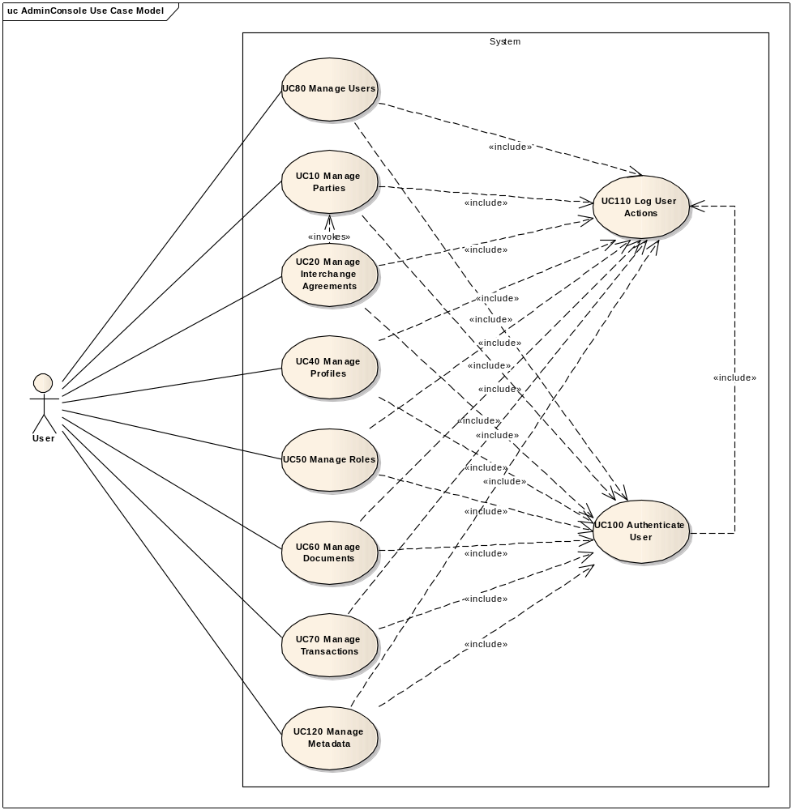

Manage Metadata module
The diagram below depicts how this use case interacts with other use cases implemented in the Administration Console.
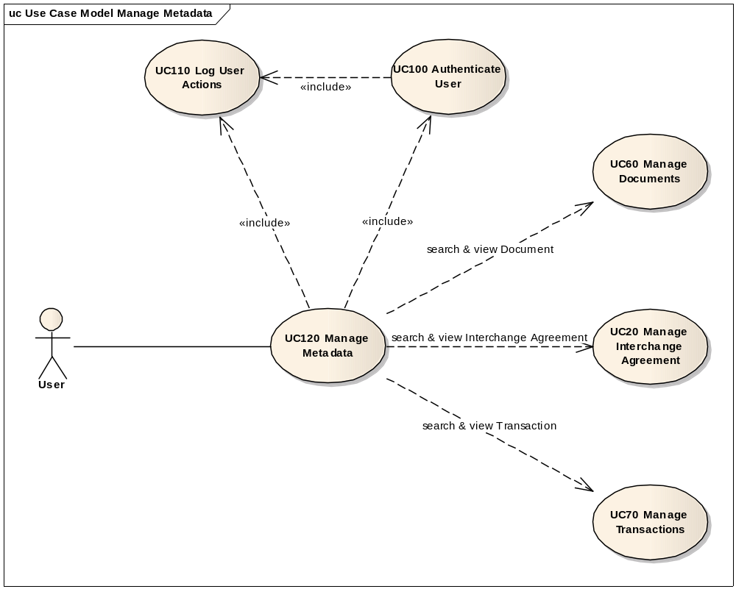

Flow of events
The conventions described in User Interface Generic Conventions document must be applied.

Basic Creation Flow

User chooses the Create Metadata menu action
ID | Description
UC120_BR01 | User needs to have the correct access rights in order to access this feature. Please see UC 0100 - eTrustEx Admin Console - Authenticate and Authorise User, section 6.3 User Access Rights for more information.
User selects the Create option by following Technical Configuration => Metadata menu path of the e-TrustEx Administration Console home page.

System displays the "Create Metadata" page
The System displays the Create Metadata page as described in paragraph 7.1. "Create Metadata" page.

User enters information and chooses the Save option

System creates the Metadata
ID | Description
UC120_BR02 | Metadata type is mandatory.
UC120_BR03 | Metadata value must not be null, but could be an empty string.
UC120_BR04 | When saving the metadata, the leading and trailing spaces of the fields are ignored.
UC120_BR05 | If Profile is specified, it shall pertain to the current business domain.
UC120_BR06 | If Interchange Agreement is specified, it shall pertain to the current business domain.  Note: The business domain of an interchange agreement can be determined by looking at the business domain of one of the parties involved in the interchange agreement.
UC120_BR10 | If Party is specified, it shall pertain to the current business domain.

- System validates the page according to the business rules.
- System saves the Metadata Item. Note: The metadata value may contain special characters, thus it needs to be saved in a format that allows them to be stored correctly (e.g. UTF-8).
- System logs the successful creation: include use case Log CIPAdmin User Actions
- System informs the user about the success of the operation

User acknowledges the successful message

System redisplays the saved Metadata Item in view mode
- System goes to step 2.3.2 in "2.3. Basic View Flow".

The basic creation flow ends.

Basic search flow
ID | Description
UC120_BR01 | User needs to have the correct access rights in order to access this feature. Please see UC 0100 - eTrustEx Admin Console - Authenticate and Authorise User, section 6.3 User Access Rights for more information.

User selects the Search Metadata menu action
User selects the Search option by following Technical Configuration => Metadata menu path of the e-TrustEx Administration Console home page.

System displays the "Search Metadata" page
System displays the search page as described in paragraph 7.2. "Search Metadata" page.

User enters the search criteria
- User enters one or more search criteria. A search criterion left empty means the concerned field will not be taken into account. The user can search by:
    - Type of metadata
    - Document
    - Interchange Agreement
    - Party
    - Profile
    - Transaction
- User activates the search button.

The System searches the Metadata Items
ID | Description
UC120_BR07 | A field left empty or containing only spaces is not taken into account during the search.
UC120_BR08 | Character case is ignored.
UC120_BR09 | At least one search field should be filled in.
The system searches the metadata items that satisfy all the entered criteria.

System displays the Metadata Items found
The system displays the list of Metadata Items coresponding to the search criteria, showing the following information:
  - Metadata Type
  - Document name and version
  - Interchange Agreement id
  - Party name
  - Profile name
  - Transaction name and version

User views the result list
- User can view the details of a Metadata Item by clicking on its corresponding line in the list (see 2.3. Basic Visualization Flow)
- User can launch a new search

The basic search flow ends.

Basic Visualization Flow
ID | Description
UC120_BR01 | User needs to have the correct access rights in order to access this feature. Please see UC 0100 - eTrustEx Admin Console - Authenticate and Authorise User, section 6.3 User Access Rights for more information.

At 2.2.6, User clicks a Metadata Item in the list

System opens the Metadata Item visualization page (see 7.3."View Metadata Item" page):
- System reads the data
- System loads data on screen
- All fields are protected
- "Cancel", "Edit" and "Delete" buttons are made available

User visualises the details of the Metadata Item:
- User can also visualize the details of a document, an interchange agreement, a party or a transaction for which the metadata is configured, by choosing the View option next to the desired information.
- User can return to the result list by choosing "Cancel", the view flow ends and basic search flow restarts at 2.2.6
- User can choose to edit or to delete a Metadata Item (see 2.4 Basic Modification Flow and 2.5. Basic Deletion Flow)

Visualization flow ends.

Basic Modification Flow
ID | Description
UC120_BR01 | User needs to have the correct access rights in order to access this feature. Please see UC 0100 - eTrustEx Admin Console - Authenticate and Authorise User, section 6.3 User Access Rights for more information.

At 2.3.3., The User chooses to edit a Metadata Item

System opens the Metadata page in edit mode (see 7.4."Modify Metadata Item" page):
- All fields can be modified;
- "Cancel", "Reset" and "Save" options are present.

User makes the changes
- User makes the desired changes
- User chooses the save option

The system saves the modified Metadata Item
ID | Description
UC120_BR02 | Metadata type is mandatory.
UC120_BR03 | Metadata value must not be null, but could be an empty string.
UC120_BR04 | When saving the metadata, the leading and trailing spaces of the fields are ignored.
UC120_BR05 | If Profile is specified, it shall pertain to the current business domain.
UC120_BR06 | If Interchange Agreement is specified, it shall pertain to the current business domain.  Note: The business domain of an interchange agreement can be determined by looking at the business domain of one of the parties involved in the interchange agreement.
UC120_BR10 | If Party is specified, it shall pertain to the current business domain.

- The system validates the page according to the business rules.
- The system saves the Metadata Item.
- System logs the successful modification: include use case Log CIPAdmin User Actions
- The System informs the user about the success of the operation

User acknowledges the successful message

System redisplays the metadata item in view mode (see 7.3."View Metadata" page)

The Modification flow ends.

Basic Deletion Flow
ID | Description
UC120_BR01 | User needs to have the correct access rights in order to access this feature. Please see UC 0100 - eTrustEx Admin Console - Authenticate and Authorise User, section 6.3 User Access Rights for more information.

At 2.3.3., User chooses to delete a Metadata Item

System displays a dialog window asking for deletion confirmation

User confirms the deletion
If user chooses to cancel the deletion, he is returned to the visualization page (2.3.3.).

System deletes the Metadata Item
- System verifies the business rules
- System deletes the Metadata Item
- System logs the successful deletion: include use case Log CIPAdmin User Actions

System notifies user of the success of the operation

User acknowledges the message

The Deletion Flow ends.

Alternative Flows

AC1: at step 2.1.3., User chooses Cancel option
- System disregards all information provided by User
- System closes the page
- System redirects the user to CIPAdmin home page
- Use Case ends

AC2: at step 2.1.3, User chooses Clear option
- Systems disregards all information provided by the user
- Alternate flow ends and basic creation flow restarts at 2.1.2.

AS1: at step 2.2.4, no metadata item found for the specified criteria
- The system notifies the user that no metadata items have been found
- Alternate flow ends and basic search flow restarts at 2.2.3

AM1: at step 2.4.3, User chooses Cancel option
- System disregards all information provided by User
- System closes the page
- Alternate flow ends and basic flow restarts at 2.3.2 (visualization page).

AM2: at step 2.4.3, User chooses Reset option
- Systems disregards all information provided by the user
- Alternate flow ends and basic modification flow restarts at 2.4.2.

A1: at steps 2.1.3, 2.2.3 or 2.4.3, User chooses to search for a Document
- System opens a Document Search Popup: include section 2.2. Basic Search Flow (from step 2.2.2. System displays the Search Document page) of Manage Document Use Case.
- System fills in the read-only input text with the name and version of the document returned at previous step
- Alternate flow ends and basic flow continues at 2.1.3, 2.2.3, respectively 2.4.3.

A2: at steps 2.1.3, 2.2.3 or 2.4.3, User chooses to search for an Interchange Agreement
- System opens an Interchange Agreement Search Popup: include section 2.3. Basic Search Flow (from step 2.3.2. System displays the Search Interchange Agreement page) of Manage Interchange Agreement Use Case.
- System fills in the read-only input text with the interchange agreement id of the interchange agreement returned at previous step
- Alternate flow ends and basic flow continues at 2.1.3, 2.2.3, respectively 2.4.3.

A3: at steps 2.1.3, 2.2.3 or 2.4.3, User chooses to search for a Party
- System opens a Party Search Popup: include section 2.2. Basic Search Flow (from step 2.2.2. System displays the Search Party page) of Manage Party Use Case.
- System fills in the read-only input text with the party name of the party selected at the previous step
- Alternate flow ends and basic flow continues at 2.1.3, 2.2.3, respectively 2.4.3.

A4: at steps 2.1.3, 2.2.3 or 2.4.3, User chooses to search for a Transaction
- System opens a Transaction Search Popup: include section 2.3. Basic Search Flow (from step 2.2.2. System displays the Search Transaction page) of Manage Transaction Use Case.
- System fills in the read-only input text with the name and version of the transaction returned at previous step
- Alternate flow ends and basic flow continues at 2.1.3, 2.2.3, respectively 2.4.3.

A5: at steps 2.1.3, 2.2.3 or 2.4.3, User chooses to clear the selected Document, Interchange Agreement or Transaction
- User chooses the clear button next to the field he / she wants to clear
- System removes the selected value from the read only field
- Alternate flow ends and basic flow continues at 2.1.3, 2.2.3, respectively 2.4.3.

A6: at steps 2.3.3, User chooses to visualize the Document, Interchange Agreement, Party or Transaction
- User chooses View option next to the information to vizualize
- System opens a View Popup showing the details of the concerned intormation:
Information type | Section to include | Start step | UC
Document | 2.3. Basic Visualization Flow | 2.3.2. System opens the document visualization page | Manage Document Use Case
Interchange Agreement | 2.4. Basic Visualization Flow | 2.4.2. System opens the "Interchange Agreement Visualization" page | Manage Interchange Agreement Use Case
Party | 2.3. Basic Visualization Flow | 2.3.2 System opens the "Party Visualization" page | Manage Party Use Case
Transaction | 2.3. Basic Visualization Flow | 2.3.2. System opens the transaction visualization page | Manage Transaction Use Case
- Alternate flow ends and basic flow continues at 2.3.3.

Exceptional Flows

E1: at steps 2.1.1, 2.2.1, 2.4.1 or 2.5.1 user is not authorized for the operation
Include the steps in section 2.4.1 of Authenticate and Authorise User Use Case.

E2: at step 2.1.4 or 2.4.4, Business Rules are not verified
- System logs the error: include use case Log CIPAdmin User Actions
- The system highlights the field(s) in error
- The System displays the error messages.
- Flow restarts at 2.1.3, respectively 2.4.3.

E3: at step 2.1.4 or 2.4.4, there is an error when saving the metadata
- System logs the error: include use case Log CIPAdmin User Actions
- The system informs the user about the error.
- Use case ends.

E4: at step 2.5.4, there is an error when deleting the metadata
- System logs the error: include use case Log CIPAdmin User Actions
- The system informs the user about the error.
- Use case ends.

E5: at any step, a technical error occurs
- System logs the error: include use case Log CIPAdmin User Actions
- The system informs the user about the error.
- Use case ends.

Special Requirements

Interface(s) with other Systems

Security Requirements

Other Special Requirement

Preconditions
- User must be registered user of CIPAdmin tool

Post conditions
- [Success] The Metadata has been successfully created / modified / visualised / deleted.
- [Failure] The System logs the failure reason and the context, the use case is aborted and the primary actor has been notified of the reasons.

Additional Information

Includes
- For operation authorization: UC 0100 - eTrustEx Admin Console - Authenticate and Authorise User
- For logging: UC 0110 - eTrustEx Admin Console - Log CIPAdmin User Actions
- For searching or visualizing a document: UC 0060 - eTrustEx Admin Console - Manage Document
- For searching or visualizing an interchange agreement: UC 0020 - eTrustEx Admin Console - Manage Interchange Agreements
- For searching or visualizing a party: UC 0010 - eTrustEx Admin Console - Manage Parties
- For searching or visualizing a transaction: UC 0070 - eTrustEx Admin Console - Manage Transaction

Extends

Mock-up screens

"Create Metadata Item" page
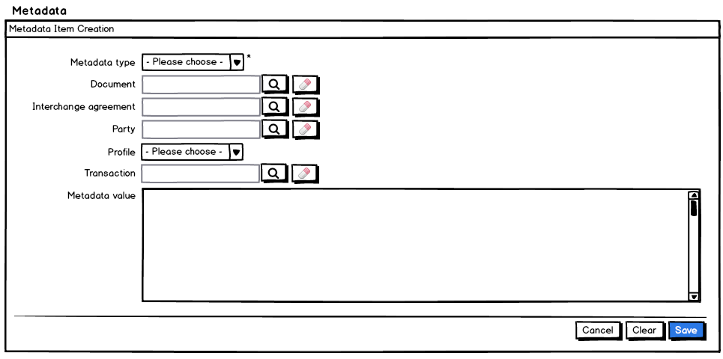
- The System fills in the Metadata type list (technical note: the values correspond to the ones in MetaDataItemType enum), ordered in ascendant alphabetical order and ignoring case.
- The System retrieves all profiles corresponding to the currently selected business domain and populates the profile list, ordered in ascendant alphabetical order and ignoring case.
- The document, interchange agreement, party and transaction fields are read only. They are automatically filled in by the system when user selects a document, interchange agreement, party or transaction in the corresponding search page that can be accessed via the search button next to the concerned field.
- The clear button next to each read only field, gives the option to clear the content of the corresponding field
- Starred fields are mandatory.
- Clear, Cancel and Save options are present.

"Search Metadata" page
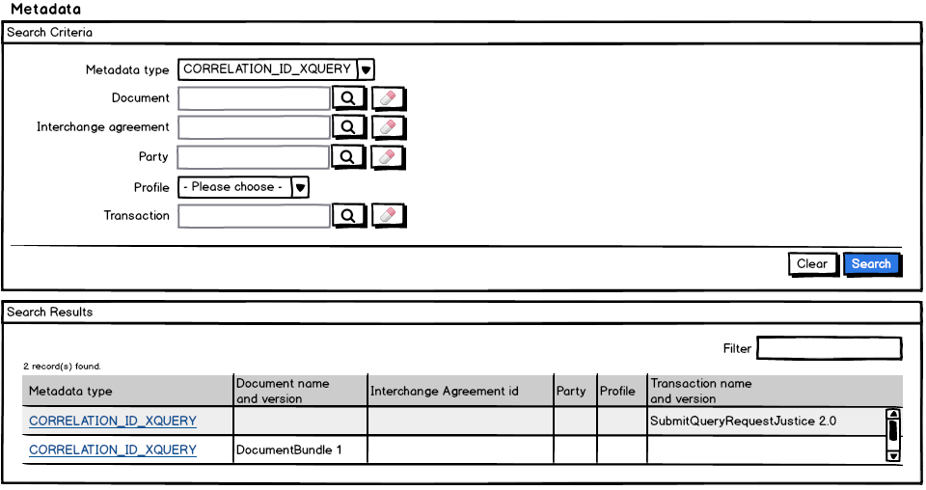
- Search Criteria section
  - See points (1) to (4) from section 7.1. "Create Metadata Item" page.
  - Clear and Search options are present.
- Search Results section
  - The number of results found is shown to the user
  - A filter on the results is also made available to the user
  - The results list shows the following information
    - The metadata item type
    - The document version and name
    - The interchange agreement id
    - The party name
    - The profile name
    - The transaction name and version
  - The results list is ordered by metadata type in ascendant alphabetical order and ignoring case.
  - The metadata item type in the results list is interactive, and clicking on it will show the item details

"View Metadata Item" page
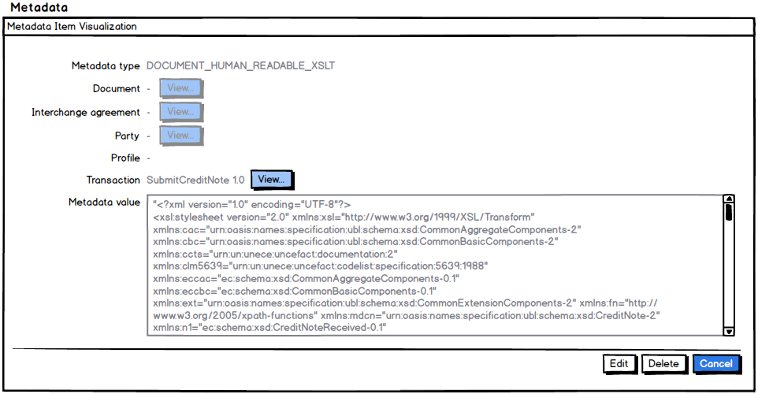
- The System shows
  - The metadata item type
  - The document name and version
  - The interchange agreement id
  - The party name
  - The profile name
  - The transaction name and version
  - For points (b) to (e) the system gives the user the option to see the details in case data is present (see View button next to each of these fields). Note that the button is protected if no data exists.
- Edit, Delete and Cancel options are present.

"Modify Metadata Item" page
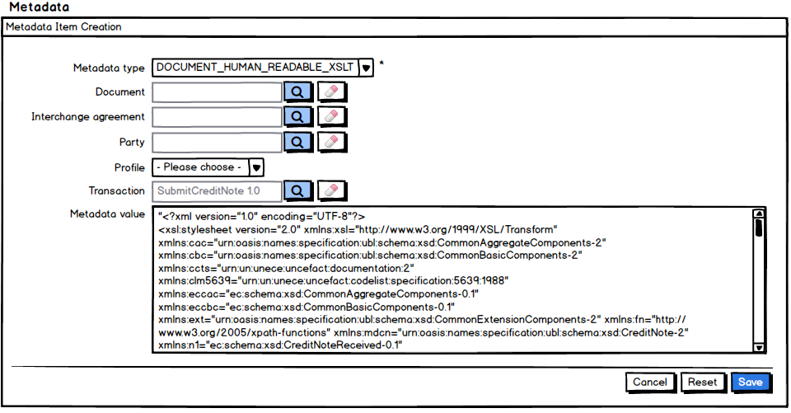
- See points (1) to (5) from section 7.1. "Create Metadata Item" page
- Cancel, Reset and Save options are present.

"Delete Metadata Item" page
